Kevin Sekuj

2/22/2022

CS325: Analysis of Algorithms

Homework 7

1. BFS and DFS for a graph starting from node A
   1. BFS: { A, B, D, F, G, C, E }
   2. DFS: { A, B, F, C, D, E, G }
   3. MinPuzzle.py
   4. Let M be the rows of the matrix and N be the columns of the matrix. At the worst case, we’ll have to traverse all cells of a matrix which gives us a time complexity of O(M\*N). We also have to consider the minheap which would in the worst case be containing M\*N cells, so updating the minheap would be an O(log(M\*N) operation. Thus, the time complexity is **O((M\*N) \* log(M\*N)).**

Dijkstra’s algorithm will not work on a graph with negative weights due to how the algorithm operates. It assumes the graph edges are weighted and are non-negative, because the algorithm operates greedily, choosing the local optimal edge in order to obtain the globally optimal solution.

If we had negative weights in a graph, they might be hidden by a positive weight that isn’t the local optimal edge, so the algorithm will make the wrong choice in terms of obtaining the shortest weighted path, as shown below.

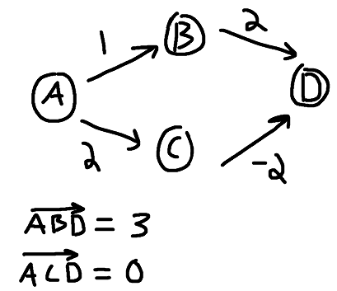

* 1. BFS: { A, B, C, D, E, G, F, I, H, J}
  2. DFS: { A, B, C, D, G, F, H, I, J, E}